
Total:95
Weighting 4%
Year 11 ATAR Geography
Task 4A - Fieldwork Booklet
MARKING KEY
Unit 2 – Global Networks and Interconnections
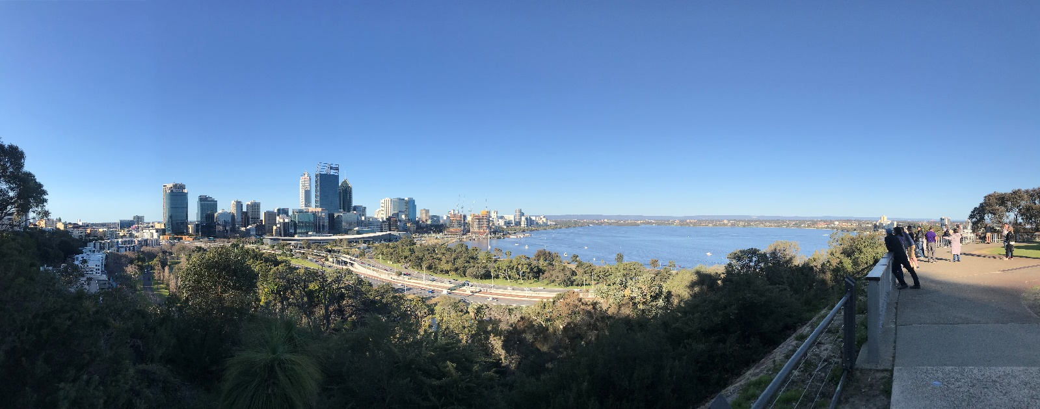
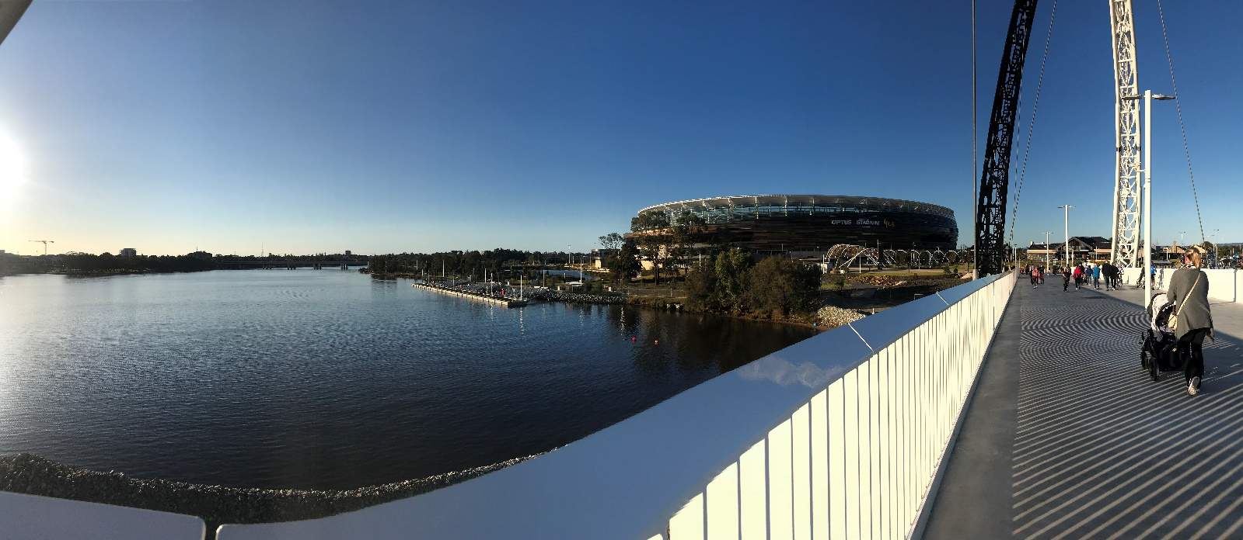
Depth Study One – Tourism
Name: _________________________________________
Date: __________________________________________
Site One: Optus Stadium
- Outline 2 Site and 2 Situation features or characteristics of Optus Stadium: (4 marks)
Site
- Correctly identifies a site feature of Optus Stadium: “Sited on the Burswood Peninsula, on cleared swamp land.

- Sited on the perennial river, the Swan River.
Situation
- Distance and Direction from the Perth CBD.

- Latitude and Longitude or Situated on the Graham Farmer Freeway.

- Make a 5 list of features of Optus Stadium that make it a tourism asset: (5 marks)
- Proximity to the CBD
- Capacity of seats for spectators
- Multifaceted venue for a variety of different events
- Food and beverage vendors
- Accessibility via a wide range of public transport
- Describe the role of Government at Optus Stadium. (2 marks)
State Government of Western Australia, responsible for the development of the site and the building/construction of the infrastructure, their role is involved in the development of Optus Stadium and outsourcing the operations with a private enterprise.
- State an example of an enterprise at Optus Stadium and briefly describe the role of they have at Optus Stadium. (Hint: How do they contribute to tourism?) (2 marks)
Depends on the example- could be Venues Live, AFL, BHP Boardwalk
1 mark or stating the example, and 1 mark for a correct description of the role they play contributing to tourism at Optus Stadium.
- List 4 transport options used to access Optus Stadium. (4 marks)

- Transperth Bus Station
- Taxi/Uber
- Ferry
- Water Taxi
- Private Vehicle
- Transperth Train
- Foot bridge - walking
- Make notes and observations during your tour of Optus Stadium; particularly in relation to tourism in Perth and the role of Optus Stadium. (20 marks)
Name of Tour Guide: ____________________________________________________________________________

Marks for detail of notes: See the rubric and description below:
Marks | 0-5 | 5-10 | 10-15 | 15-20
Description | Very brief notes, less than 5 dot points  Not much of an attempt in completing notes during the tour of Optus Stadium | Brief notes, at least 5 dot points.  Some effort in completing notes during the tour, include features of the stadium and statistics | Good detail in the notes. 5 or more dot points.  Clear effort in completing notes during the tour, including features of the stadium, statistics and how it contributes to tourism. | Excellent detail in the notes, at least 8 dot points.  Clear effort in completing notes during the tour, including features of the stadium, statistics and how it contributes to tourism.

- Field sketch: Arriving at Gate C looking out over towards the CBD in a westerly direction, complete a quick sketch of the area in front of you. Remember to use pencil and include a title. (8 marks)

1 mark for labelling each of the following: (total of 6)
- Swan River
- Central Business District
- Optus Stadium
- BHP Boardwalk
- Matagarup Bridge
- Hotels in South Perth

Hints:
- Only show main features
- Make sure your sketch is clear and easy to read/understand
- Ensure you annotate your sketch by adding brief notes (2 – 3 words for each note)
- You may like to use a key to add extra notes
- It highlights main features, including elements above
 | Excellent (2) | Average (1) | Poor (0)
Sketch 1  Detail and Presentation | Sketch 1 detailed and clearly drawn and most main features labelled/ annotated. Appropriate title is used. Pencil is used on sketch. | Sketch 1 lacks some detail or not clearly drawn and some main features are labelled. A basic title is provided and pencil may be used. | Sketch 1 lacks detail or is too messy or incomplete; limited labels and some are difficult to interpret the labels. Title is used, however may not be appropriate. Pencil may be used.

Site Two: Kings Park and Botanic Garden
- Outline 2 Site and 2 Situation features or characteristics of Kings Park and Botanic Garden: (6 marks)
Site
- Sited on Mount Eliza.
- Sited on 300 hectares of dense natural bushland and 100 hectares of cleared parkland.

Situation
- Latitude and longitude.
- Distance and direction from the Perth CBD
- Make a 5 list of features of Kings Park and Botanic Garden that make it a tourism asset: (5 marks)

- Scenic views of the Perth CBD, South Perth and surrounding metropolitan area
- Parkland facilities for recreational activities
- Botanic gardens
- footbridge
- Rio Tinto Naturescape playground
- Outdoor Auditorium
- Bicycle paths etc
- Describe the role of Government at Kings Park and Botanic Garden. (2 marks)
1 mark for the name of the Botanic Gardens Park Authority– their role of management and conservation of the park and WA’s floral features
- State an example of an enterprise at Kings Park and briefly describe the role of they have at Kings Park and Botanic Garden. (Hint: How do they contribute to tourism?) (2 marks)
Could refer to Aspects Gallery, Food Vendor, Rio Tinto, Hop On/Hop Off Bus etc.
1 mark for stating the enterprise
1 mark for a description of their role in relation to tourism
- List 4 transport options used to access Kings Park and Botanic Garden. (4 marks)

- Free cat bus/ transperth bus
- Private car
- taxi
- walking
- bike
- tour bus
- Make notes and observations during your tour of Kings Park and Botanic Garden; particularly in relation to tourism in Perth and the role of Kings Park and Botanic Garden. (20 marks)

Name of Tour Guide: _____________________________________________________________________________
Marks for detail of notes: See the rubric and description below:
Marks | 0-5 | 5-10 | 10-15 | 15-20
Description | Very brief notes, less than 5 dot points  Not much of an attempt in completing notes during the tour of Kings Park | Brief notes, at least 5 dot points.  Some effort in completing notes during the tour, include features of Kings Park and statistics | Good detail in the notes. 5 or more dot points.  Clear effort in completing notes during the tour, including features of Kings Park, statistics and how it contributes to tourism. | Excellent detail in the notes, at least 8 dot points.  Clear effort in completing notes during the tour, including features of Kings Park, statistics and how it contributes to tourism.

- Survey (5 marks) – unable to complete survey due to wet weather
1 mark per question – question should be in clear question format and be an appropriate question to relating to tourism with the purpose of gathering date about tourists visits to Kings Park

16: What if… there is a cable car built that connected Kings Park to Elizabeth Quay. Describe the potential impacts this would have on the following: (6 marks)
2 marks per section
- Economy
1 mark – mentioning the cost of construction on state government
1 mark – potential for raising revenue, by charging tourists to use the cable car

- Visitors to Kings Park
1 mark – another option for accessibility to Kings Park and connects Perth CBD to the park.
1 mark – quicker transport option, another activity for tourists to partake in

- The Environment
1 mark – mention the disruption to the view of the natural environment
1 mark – increased demand and visitors has the potential to disturb the natural environment further.

